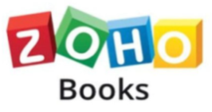

|  |  |
| --- | --- |
| COURSE NAME: | FINANCE & ACCOUNTING WITH ZOHO BOOKS |
| PROJECT TITLE: | PREPARATION AND MAINTENANCE OF ZOHO BOOKS FOR DREAM HOMES REALTY |
| PROJECT SUBMITTED TO: | SMART INTERNZ |
| YEAR: | 2023-2024 |
| DEPARTMENT: | COMMERCE (CA) |
| SEMESTER: | V |
| TEAM ID: | NM2023TMID09323 |
| MEMBERS OF THE GROUP: | Register No. Student Name  1321152020 – C.Kavitha  1321152019 – P.Karthigaiselvi  1321152021 – S.Kaviya  1321152018 – M.Karthiga |
| GUIDED BY: | Ms. M. Jemima Suganthi, M.Com., M.Phil., Assistant Professor  Ms. M. Jeya Bharathi, M.Com., M.Phil., Assistant Professor |
| SPOC NAME: | Ms. K. Elizabeth, M.Sc., M.Phil., B.Ed., Assistant Professor |

**INDEX**

|  |  |
| --- | --- |
| **Particulars** | **Pg. No.** |
| Introduction | 3 |
| Problem Definition & Design Thinking | 5 |
| Result | 8 |
| Advantages & Disadvantages | 10 |
| Applications | 11 |
| Conclusion | 12 |
| Future Scope | 13 |

**PREPARATION AND MAINTENANCE OF ZOHO BOOKS FOR DREAM HOMES REALTY**

**1.INTRODUCTION**

Zoho books is a one stop platform for maintaining our accounting task and organising our transaction.

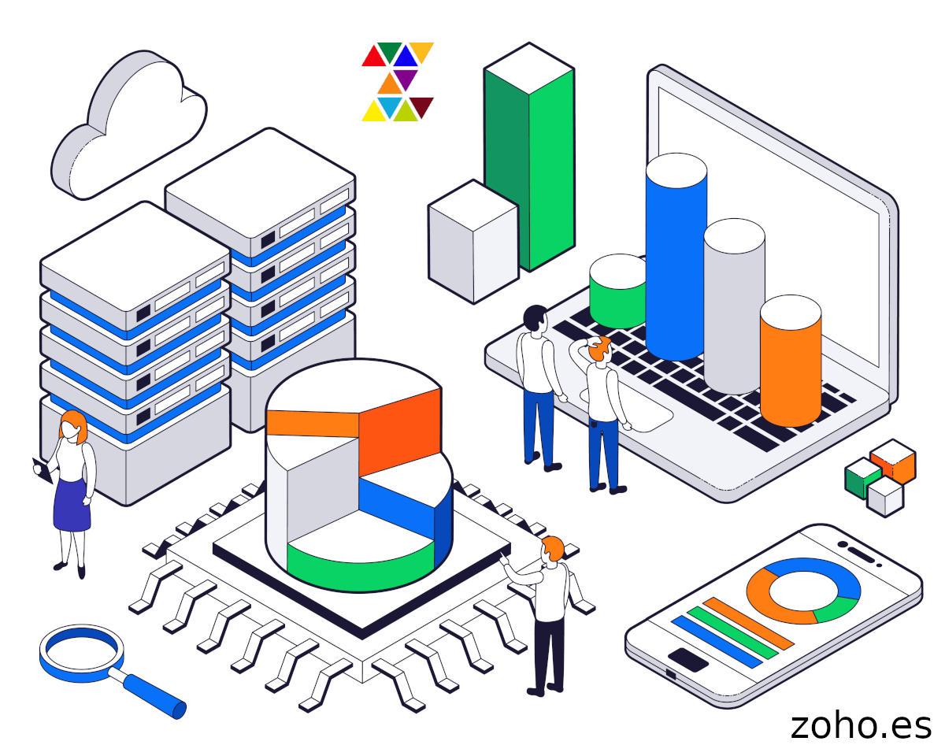

**1.1 Overview :**

**1.** The Navigation Panel on the left-hand side lists all the modules of Zoho Books.

**2.**Get into the Sales tab and the Purchases tab to manage Quotes, Invoices, Expenses, Bills, and more.

**3.** The Quick Create button by the respective modules is the shortcut to create new transactions.

**4.** The Quick Create option can be used to create a transaction on the fly from anywhere in Zoho Books.

**5.**Clicking on the Recent Activities option will display of list of most recent transactions we have carried out in our organization.

**6.**Use the Search bar to quickly find a specific transaction, contact, item or more.

**7.**The Notifications Section will notify we of any customer activity on the customer portal as well as announcements from the Zoho Books team.

**8.**Click on the Settings icon to manage our Organization Profile, Users, Subscriptions and more.

9. Drill further in Zoho Books using help and Webinars or contact support from the Help section.

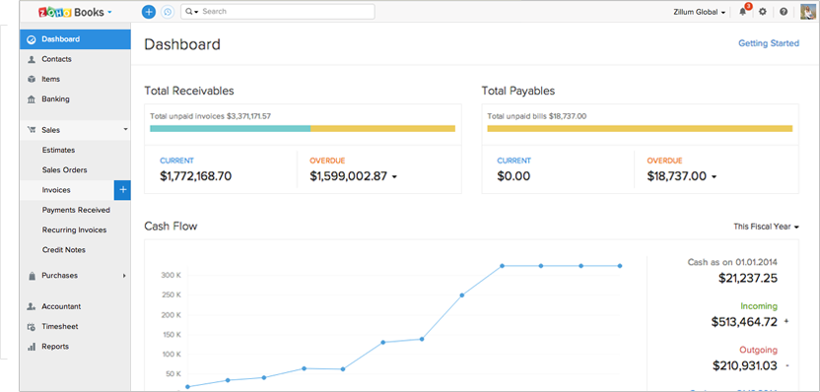

**1.2 Purpose**

Zoho books is an online accounting application that take care of accounting needs of our business. We can record, audit and analyze all financial transactions easily.

Zoho Docs is an online document management system with built-in online editors to create and edit files. All our files are in cloud and can be easily accessed from any location and from any device. It allows we to create, share, collaborate, and manage all our business documents from one single location.

**2. PROBLEM DEFINITION & DESIGN THINKING**

**2.1 Empathy Map**

An empathy map helps to map what a design team knows about the potential audience. This tool helps to understand the reason behind some actions a user takes deeply. This tool helps build Empathy towards users and helps design teams shift focus from the product to the users who are going to use the product.

Empathy maps are used to gain a 360-degree perspective on what a user says, thinks, feels, and does. Empathy maps offer a glance into who a user is as a whole, and what they feel is different from what they say, think, or do.

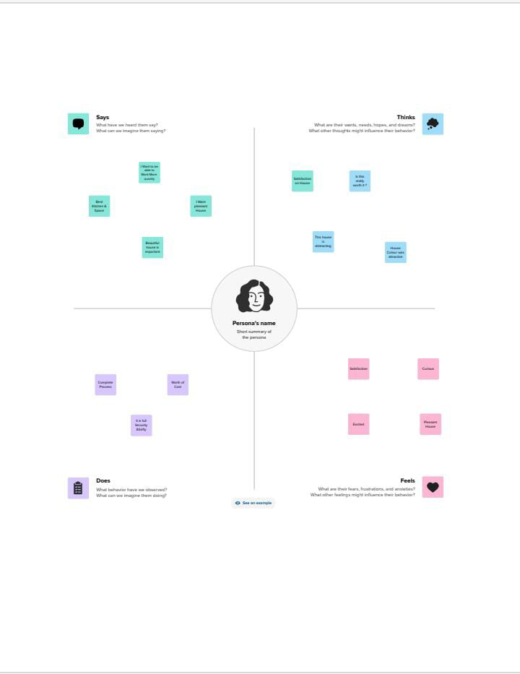

**2.2 Ideation and Brain storming Map :**

A mind map is a visualization technique and brainstorming tool which allows we to explore a central idea, and all of its related topics, in a non-linear way. When brainstorming, or attempting to see a particular topic from all angles, linear tools like lists aren't always the best solution.

Come up with three to five main ideas, then evenly space them in a circular formation around the mind map topic. Draw a line from the mind map topic to each main idea. Brainstorm supporting details such as ideas, tasks, and questions for each main idea. Draw lines connecting each main idea to its supporting details.

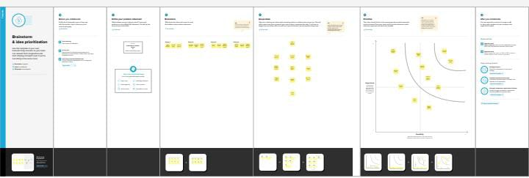

**3. RESULT**

**Profit & loss**

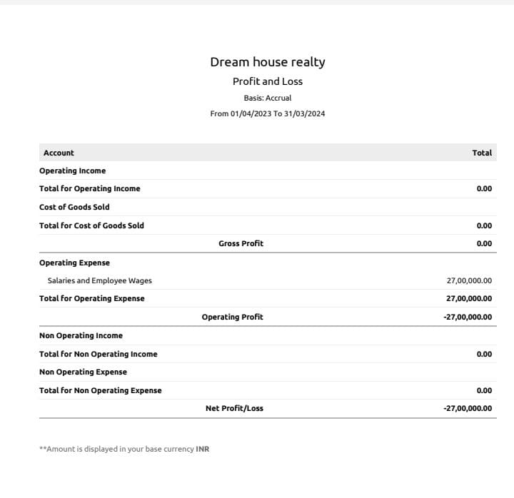

**Balance Sheet**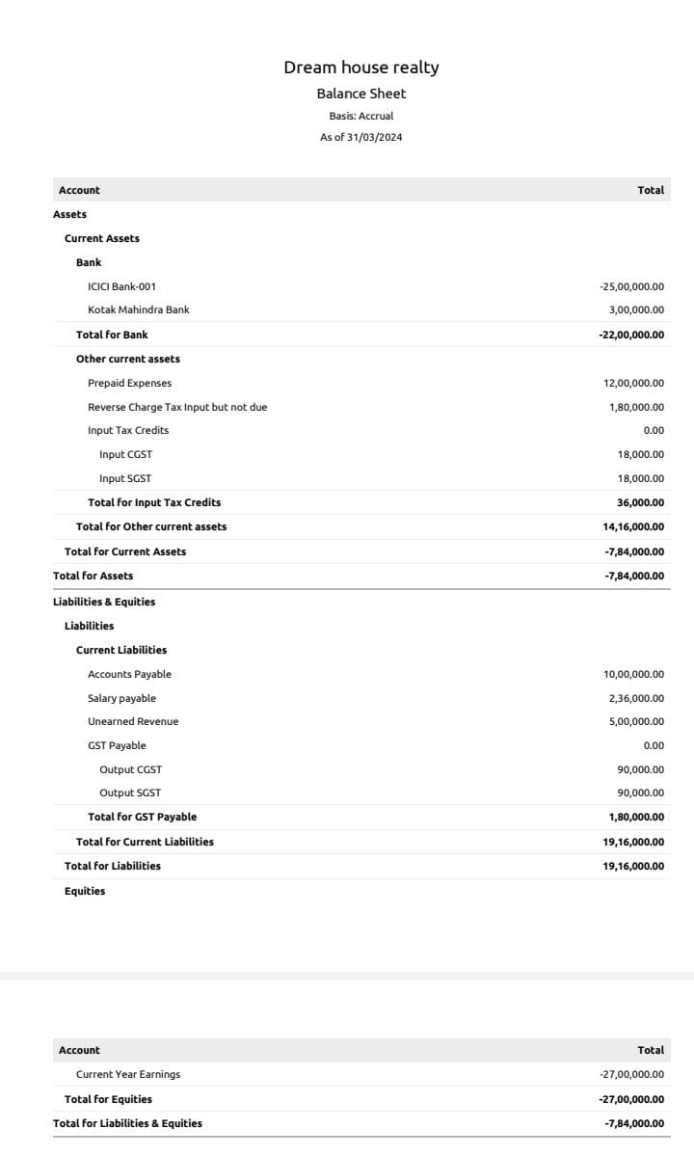

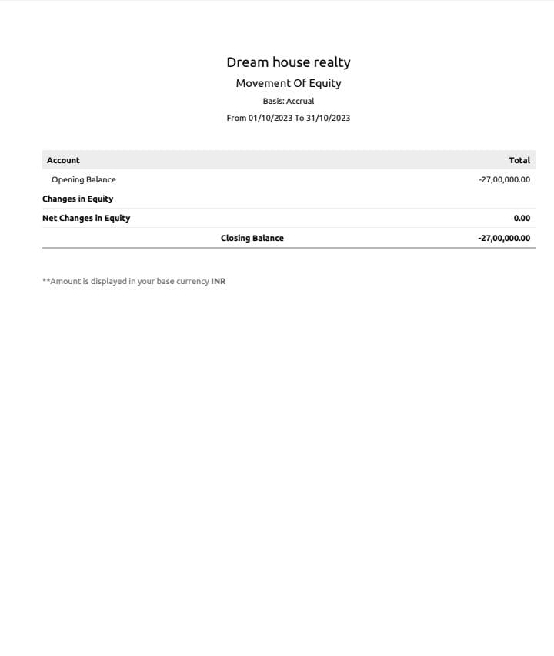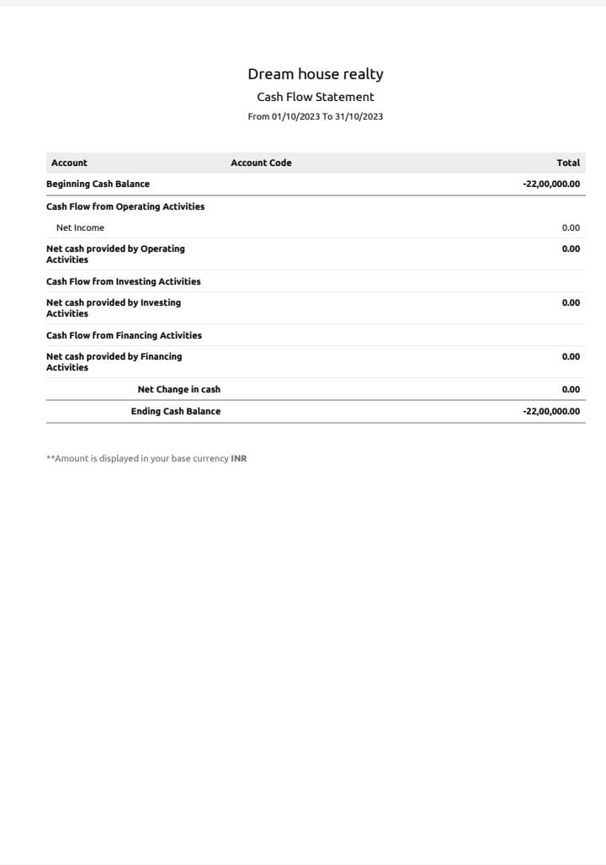

**4. ADVANTAGES & DISADVANTAGES**

Invoicing and billing are essential business functions and the primary source of cash flowing into our business. However, managing invoices manually is time-consuming and error-prone.

Zoho Books addresses these issues effectively and offers great features that make our invoicing easier. Zoho Books allows us to automate our payment reminders and track due dates and expected payment dates. So, it can send them to our customers automatically.

Zoho books gives more benefit to the educonnect learning center for creating customer ,vendors ,purchase order ,sales order, bill. In addition, we can handle all kinds of currencies and connect our accounting application with Zoho Books to support multiple currencies.

Zoho Books is built to add our local tax authorities.

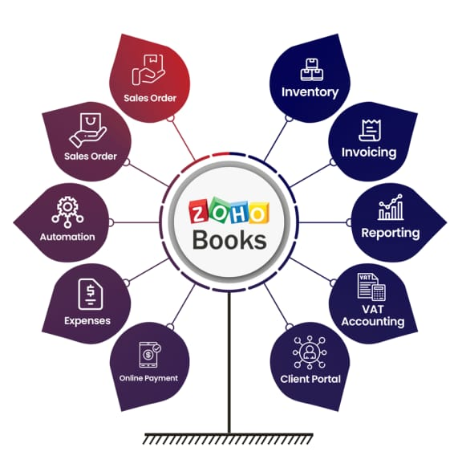

**4.1 Advantages:**

* Invoicing And Billing.
* Online Payments.
* Expense Tracking.
* Project Management & Timesheets.
* Inventory Management.
* VAT Tax Compliance.
* Report Generation.
* Reduce Overall Costs.

**4.2 Disadvantages:**

* Monthly transaction cap.
* Multiple subscriptions for multiple businesses.
* Additional users require a fee.
* Fewer integrations than competitors.
* No payroll services.
* Accounts payable limitations.

**5. APPLICATIONS:**

### Gain instant insights

Know how well our business is performing through a KPI dashboard.

### Make payments easier

Offer customers secure, and convenient online payment options.

### Send beautifully crafted invoices

Create and send personalized invoices that reflect our brand.

### Track our payables effectively

Monitor expenses and bills and see how money moves out of our business.

### Understand our financials

Generate key financial reports like balance sheets, cash flow statements, and income statements to know where our business stands.

**6. CONCLUSION :**

Zoho Books is online accounting software that manages our finances, keeps we GST Compliant, automates business workflows, and helps we work collectively across departments.

Zoho Books is a smart accounting system designed for growing businesses. It is very simple, easy to use, and able to help we make intelligent data-based decisions.

With Zoho Books, we can send professional invoices to customers and begin receiving online payments from them all from a single platform. It’s fast, powerful, and convenient, and helps regain control over the company’s finances and save more in the future. For this purpose, we can rely on features such as cash flow statements, P&L, Balance sheets, and many more.

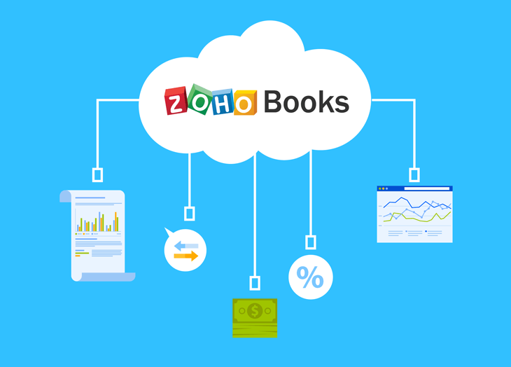

**7.FUTURE SCOPE**

Zoho development is going to focus on cloud services. Furthermore, expectations are that cloud would form 70% of Zoho's business and 30% would be from on-premise offerings. However, Zoho is going to continue its global expansion plans.

Software as a Service (SaaS) major Zoho Corp with products competing for various technology giants in the world, has recently launched Zoho One, an integrated suite, forecasting that the SaaS businesses are going the way towards integration of their offerings.

The company, which has never raised funds from outside investors or acquired a technology over two decades of its operations, is looking at new opportunities in technology and geography.